Module-End -1
Module End Assignment:
“Data Cleaning, Analysis & Visualization
with Excel”

Excel – Data Analysis and Dashboard Documentation
Microsoft Excel is a spreadsheet program developed by Microsoft that is commonly used for storing, organizing, calculating, and analyzing data. It allows data to be arranged in rows and columns and provides various tools for calculations, data cleaning, visualization, and reporting.
1. Data Sorting, Filtering and Table Creation
Excel was used to organize the data in all the sheets of the given dataset. Sorting and filtering options were applied wherever required to make the data easier to examine. The datasets were also converted into tables using Insert → Table.
2. Data Cleaning
Data cleaning involves identifying and handling missing information, duplicate records, incomplete entries, and other inconsistencies in a dataset.
a. Checking Duplicate Values
After examining the given dataset, no duplicate records were identified.
b. Identifying Missing Values
Missing values were checked using the COUNTBLANK function. The number of blank cells was calculated and the result was entered in the last row of each respective table.
Syntax:
=COUNTBLANK(range)
c. Correcting Incomplete IDs
The Find & Replace feature was used to locate and replace incomplete Product ID and Customer ID values.
d. Freezing the Header Row
For easier navigation and interpretation of the data, the top row of every table was frozen using View → Freeze Panes.
3. Removing Unnecessary Columns
The sub_category column was removed from the dataset because it was not required for the analysis.
4. Applying Excel Formulas
Different Excel formulas were applied to fill missing values and perform calculations required for analysis.
a. Handling Missing Values
The IF(ISBLANK()) function was used in the identified missing cells of each sheet.
For numerical columns, the missing values were replaced using the average value. For text-based columns, the missing entries were filled with "Unknown."
The columns where missing values were handled are identified with the name "replaced."
b. Product_Dim Sheet – Total Cost
The total Cost value was calculated in cell G103 of the Product_Dim sheet using the SUM function.
Syntax:
=SUM(number1,[number2],...)
c. Sales_Fact Sheet – Total Unit Price
The total Unit Price was calculated in cell L2003 of the Sales_Fact sheet using the SUM function.
Syntax:
=SUM(number1,[number2],...)
d. Sales_Fact Sheet – Average Discount
The average Discount value was calculated in cell M2003 of the Sales_Fact sheet using the AVERAGE function.
Syntax:
=AVERAGE(number1,[number2],...)
5. VLOOKUP and HLOOKUP
VLOOKUP
The VLOOKUP function is used to find a particular value in the first column of a table and retrieve the corresponding value from another column in the same row. It is useful when information needs to be retrieved or combined from different parts of a dataset.
Syntax:
=VLOOKUP(lookup_value,table_array,col_index_num,[range_lookup])
HLOOKUP
The HLOOKUP function works similarly to VLOOKUP, but it searches for a value across the first row of a table and returns the corresponding value from another row in the same column.
Syntax:
=HLOOKUP(lookup_value,table_array,row_index_num,[range_lookup])
6. PivotTables
A PivotTable is an Excel feature used to summarize and analyze large datasets. It can quickly calculate values such as totals, averages, counts, and percentages without requiring complex formulas.
Filters and slicers can also be used to focus on particular sections of the data. PivotTables can further be represented through PivotCharts to create more interactive reports and dashboards.
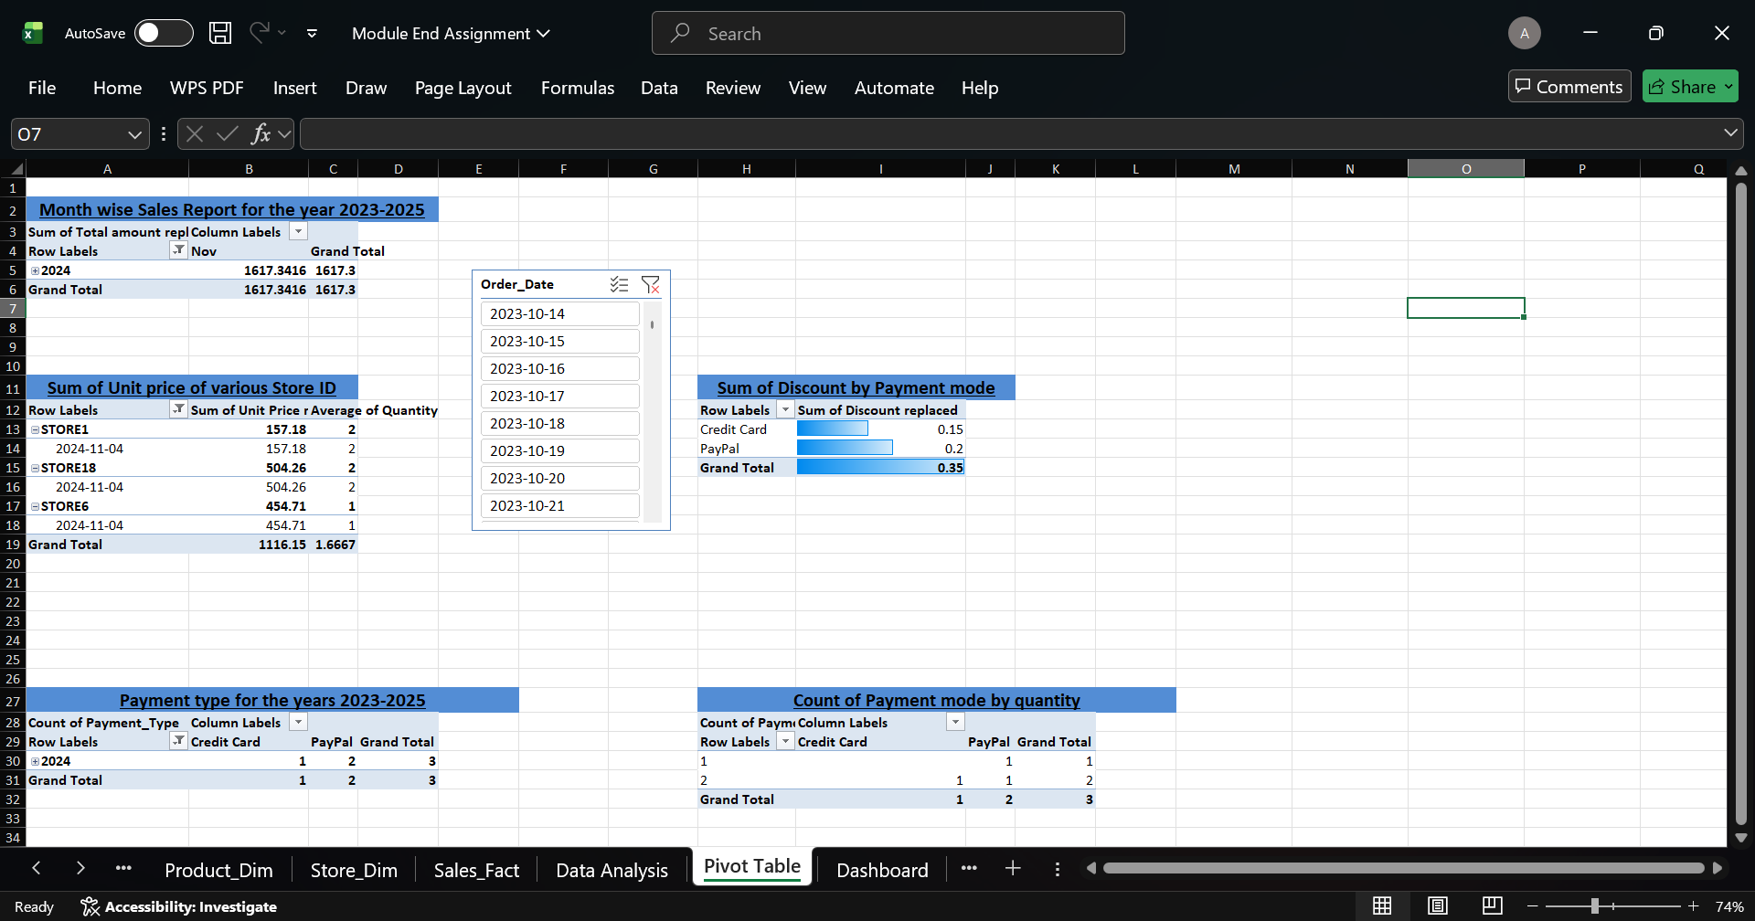
In the analysis, five PivotTables with slicers were created. Conditional Formatting was also applied to highlight the data within the PivotTables.
7. Data Analysis ToolPak
The Analysis ToolPak is an Excel add-in that provides various statistical analysis tools. The Descriptive Statistics option was used to obtain a summary of the dataset.
The analysis provides statistical values such as:
- Mean
- Median
- Mode
- Standard deviation
- Variance
- Range
- Minimum
- Maximum
- Sum
The resulting statistical analysis was calculated and presented in the "Data Analysis" sheet.
8. PivotChart
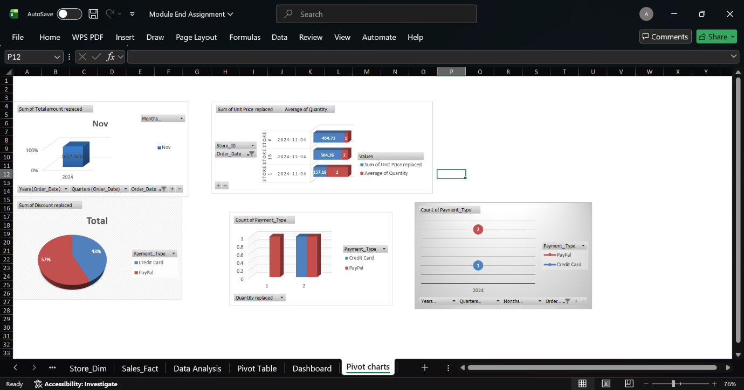
A PivotChart is a graphical representation of information from a PivotTable. It helps present analyzed data in a visual form and makes it easier to identify trends and comparisons.

Summarization of Sales Dashboard
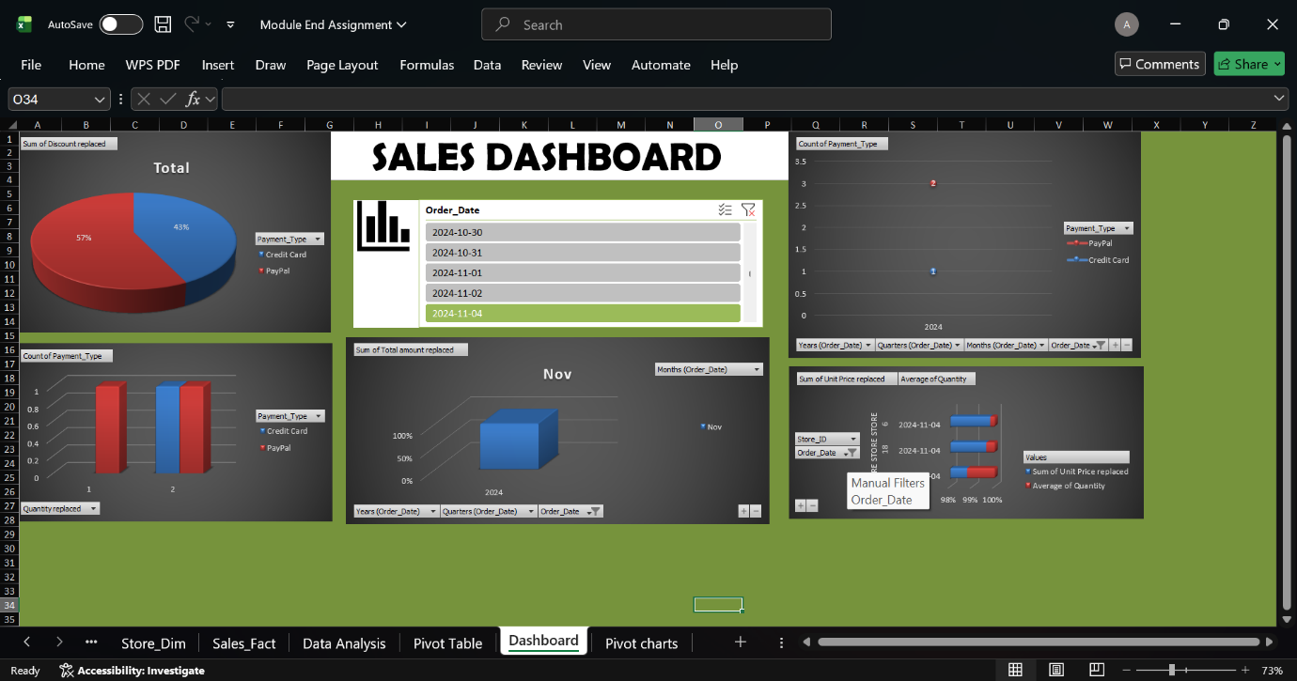
The Sales Dashboard provides a visual summary of sales and payment-related information. It combines PivotTables, PivotCharts, and slicers, allowing the information to be explored interactively.
1. Total Discounts – Pie Chart
- The pie chart represents the total discount amount according to the payment method.
- PayPal represents a larger share of the discounts.
- This shows that a greater amount of discount was associated with PayPal transactions.
- This may be related to promotional activities or the usage pattern of customers.
2. Payment Type Distribution – Bar Chart
- The bar chart displays the number of transactions for each payment method.
- Credit Card and PayPal show almost similar transaction counts.
- This indicates that both payment methods have relatively balanced usage in the dataset.
3. Sales Trend – 3D Cube Chart
- The 3D Cube Chart represents the total sales amount.
- The presence of a single cube represents the concentrated sales activity shown in the analyzed data.
4. Store Performance – Horizontal Bar Chart
- The horizontal bar chart compares unit price and quantity sold across different stores and dates.
- The results remain relatively consistent, approximately within the 98–100% range.
- This indicates stable pricing and sales volume across the different outlets.
5. Payment Timeline – Line Chart
- The line chart shows the number of payments over a period of time.
- Both payment methods are represented in the chart.
- PayPal is slightly higher than the other payment type in the displayed results, indicating a slightly greater level of usage.
6. Interactive Filters – Slicers
Several slicers were added to make the dashboard interactive. These include:
- Order Date
- Month
- Quarter
- Year
These filters allow users to select specific time periods and examine changes in sales and payment activity.
Interpretation Summary
The dashboard provides an overall visual representation of sales and payment patterns in the dataset.
- Sales activity remains relatively steady, with noticeable activity during November 2024.
- PayPal accounts for a larger share of the displayed discounts and has a slight lead in transaction usage.
- Store-level results show relatively consistent pricing and quantity trends.
- The combination of PivotTables, PivotCharts, and slicers makes it easier to compare payment methods, examine sales patterns, and review store-wise performance.

